EVS project EVS. Come. Press with BalkanKids Foundation in Varna, Bulgaria
Coordinator Denitsa Hristova, balkankids@gmail.com
How long? The project is for a six - month service period starting in fall.
What will I do? – The main focus of our activities are disadvantaged children and youngsters. Our volunteers work in a foster home with children without parents, in a daily centre with children with mental problems, blind people and children and poor children.
We organize art and sports activities in their free time. Also we make social events and EVS promotion.
The activities are 5 days a week. Bulgarian language classes are provided as well.
What is the team like? - The volunteers will be a part of a large multinational team of other volunteers – Polish, German, Spanish and Portuguese. They will have an inspiring mentor and coordinator.
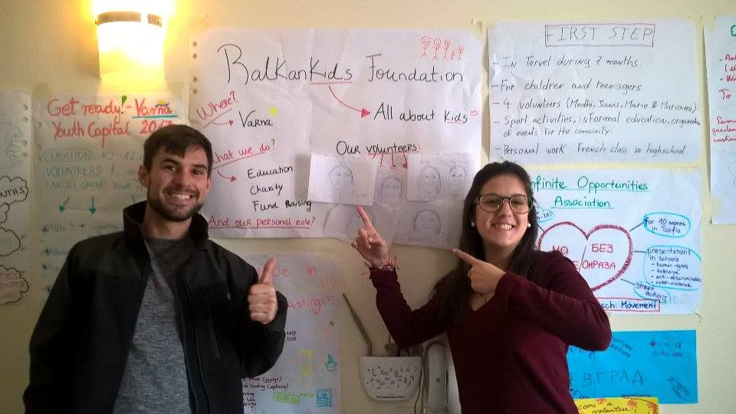
What are the practical things?
Volunteers will share a two-room flat with other volunteers – the flats will be gender-devided. The flat is modernly furnished with all necessary household appliances and in the centre of town. They will cook on their own.
Each month they will receive 70 euro pocket money and 110 euro -money for food.
Travel and phone expenses will be covered within limits. Travel to and from Varna will be arranged and covered by hosting organization.
The sending organization will make a full health insurance of volunteers.
The hosting organization will provide full organizational, mentoring and language support during the service.
Varna is European Youth Capital 2017 and a very lively and fun city.

