In 2019
Non Profit Company
“You in Europe”
Located in Greece

Welcomes 20 Volunteers
For 1 month ESC project
From Slovenia, Bulgaria, Spain and Italy

Title: “Sea u in ESC”
Dates:22/6/2019 –21/7/2019
(Including travel days)

Place: NeaMoudania, Halkidiki.

1. The place
The Municipality NeaPropontida, on the basis of the Greek Statistical Authority of the 2011 census, numbers about 36.520 inhabitants and the area of NeaMoudania, where the headquarters of the activities, collects half of the municipality population. It is the largest urban center in the region, occupying the top of the first peninsula of Halkidiki, from the boundaries with the Prefecture of Thessaloniki to the middle of the peninsula.
Regarding the age structure, NeaMoudania appears as the most dynamic with a greater percentage participation of very young ages (0-14 years, 18.8%), high turnout of new categories of 15-24 and 25-39 years (14.8% and 25.5% respectively) and relatively low rate of 65 years and older (11.3%).
NeaMoudania is a vivid commercial center, with a lot of shops, public services, bars and restaurants. During the summer, the population doubles, as it is also a famous touristic resort, due to the crystal clear waters and sandy beach.
Thessaloniki, the second biggest city of Greece is only half an hour by car and features an interesting cultural and historical background, as well as vivid nightlife.
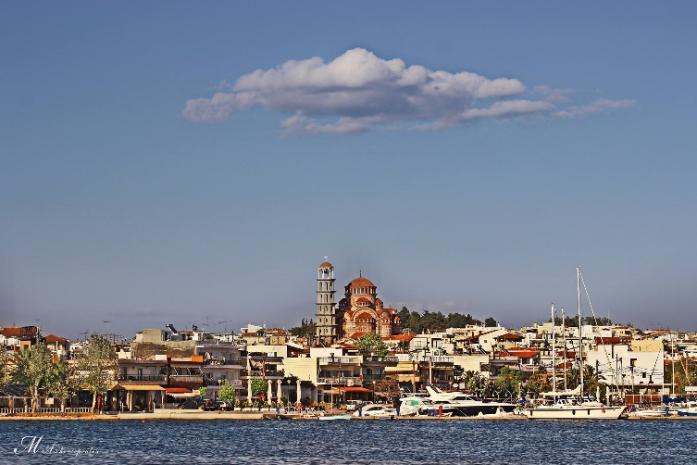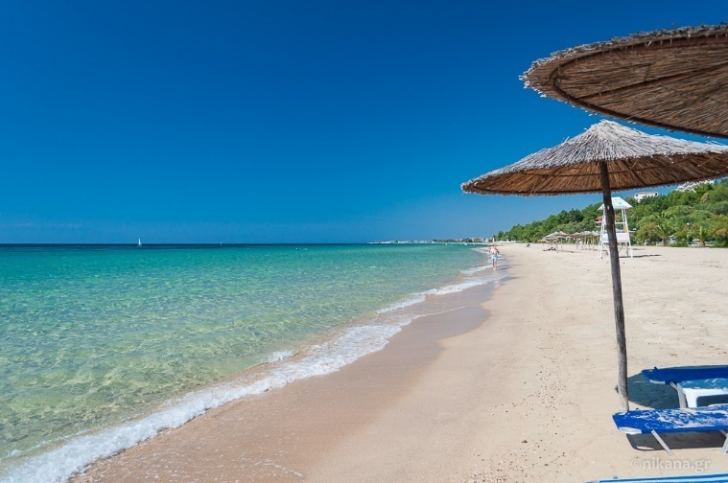
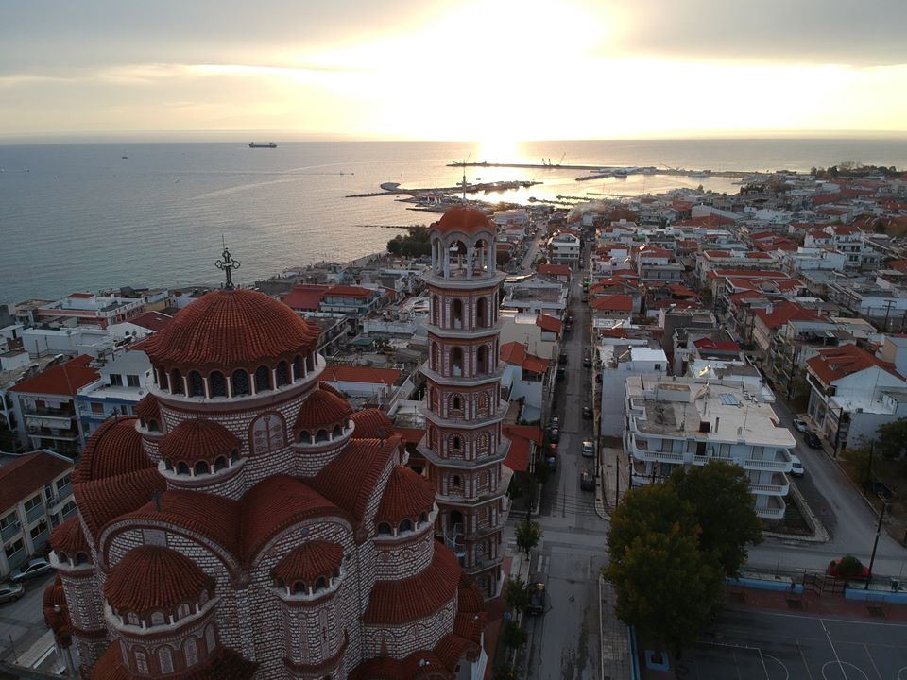

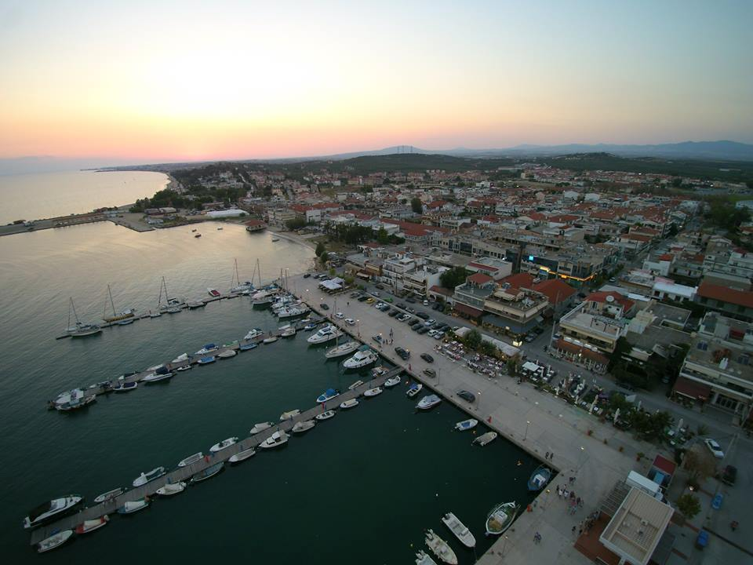

2. The hosting organization
The non-profit organization "You in Europe", which was established in 2012, has among other aims the solidarity and understanding between societies, especially in Europe. Therefore promotes volunteerism as a mean of strengthening social cohesion and equal parallel as tool for integration of people from vulnerable social groups. To achieve its objectives, seeks the creation of communication networks between populations in particular European countries. At the same time it aims at fostering the spirit of volunteerism through the implementation of European projects - in the fields of non-formal and informal learning and vocational training in collaboration with other organizations having similar purposes. The overall objectives of the organization are:
Purpose of the company is to contribute to the deepening of understanding, solidarity, communication, cultural, social, athletic and economic rapprochement of the people of Europe, particularly of the European Union.
To create social networks and communication channels between populations from various European states animated by shared values, ideas and interests.
To cultivate bonds with groups of countries that have historical, artistic and spiritual bonds with Greece.
To contribute to the study, preservation, presentation and promotion of cultural peculiarities of the people of Europe.
To contribute to the culture of local art, theater, music and dance traditions of the people of Europe.
To contribute to the study of local dialects, linguistic diversity and literary production of the peoples of Europe.
To promote the concept of volunteering and social solidarity.
To contribute in every possible means to social inclusion, economic and cultural advancement of disadvantaged population groups , such as women , children , immigrants , the poor, the disabled and the disadvantaged groups in general population of European countries .
To ensure the promotion of gender equality.
As the organization has experience in the European Voluntary Service since 2012 when it received the relevant certification as sending organization within the program "Youth in Action", by sending volunteers in Austria, Lithuania and England and worked with another entity for sending volunteer in Portugal. But the officers who compose the NGO have previously dealt with the implementation (sending and hosting) of EVS projects, have general experience of its participation in the implementation of actions of the "Youth in Action" and overall experience in the submission, implementation and monitoring of projects financed by European Structural funds.
Target group is mainly the youngsters and generally social groups experiencing exclusion and marginalization. While youth work is not recognized in Greece, however, we apply techniques and methods as they have developed by various bodies such as knowledge resource centers for youth SALTO etc.
The experience gained by our organization since its establishment until today, and without taking into account the previous experience of its executives is satisfactory. From 2012 until December 2017, we sent abroad 70 volunteers in a variety of programs, short and long term, in groups or individually. An informal network has been created and we stabilized cooperation with institutions from Portugal,Spain, Bulgaria, U.K., Romania, Poland, Italy, Latvia, Lithuania, Denmark and Austria. The process of preparation of the volunteers and the constant communication with them during their program has given the required experience to all members of our organization to handle different situations. Alongside executive who previously participated in a seminar SOHO and has been hosting project leader along with former EVS volunteer who returned and be active in our body give the required expertise for the preparation and hosting program. Simultaneously at international youth work, our institution has been involved in a sufficient number of exchanges and trainings filling eligible activities of key action 1 in the youth field.
All four key members of the organization are graduates of humanity studies, which is important both for the subject of the application and the overall involvement with youth. They have participated themselves in training activities mentioned in the above field, gaining important insights on actions for youth while the head of the EVS has been in the past (under another entity) responsible sending and hosting volunteers and participated in SOHO seminar . Finally the organization has launched the creation of a group of volunteers consisting of local residents.
1. IoannaThomopoulou: Graduate Department of Economics University of Macedonia, postgraduate degree in MBA and for 20 years works as permanent administrative employee in municipality of NeaPropontida. Currently she serves as Head of the Municipality Bodies Civil Support Department. From 2008-2012, actively dealt with the EU Youth Programs, as well as with the program "Europe for the Citizens" and Twinning, participating in the organization and implementation. Also she is involved in the organization and presentation of various cultural events of the Municipality. Through its participation in 2012 as a founding member of the "You in Europe" has gained great experience in organizing and implementing all of the above actions.
2. Grigoris Kyriakou: School of the Aristotle University archeology department, worked from his student years in EU programs concerning the informal learning in the youth field. Worked in Kilkis for 11 years, of which 9.5 in the youth sector (responsible establishment and activities of the Municipal Youth Council and the Youth Information Centre) and the rest as a special assistant of Mayor while participation in the Culture Agency. Then he was responsible of management competence for types B and C (CC 1429) in association about disability while he is still engaged in European programs concerning disabilities. From this practical specificity demonstrated in the cultural and social fields and in education, whether formal or informal. Possesses a certified (by E.O.D.D., the Open University and the University of Ioannina) knowledge in the management of European programs and project management while being registered in the register of instructors L.A.E.K.
3. Stavroula Pagona: School of Public Relations and Communication and the experience as a copywriter and later head of the creative department of various advertising companies, are a valuable asset for the exercise of activities within the body as it can assist in
-View of its actions in various tropous- print advertising, TV, internet, social media
-organization of events
-finding partners because of her comfort in communication
Receiving strategic decisions in the marketing sector
- Finding sponsorships and creating reciprocal relationships with other companies
4. Vasilis Stoulos: Graduate Engineer agronomist and graduate of the department "Studies in Greek Culture" EAP, Postgraduate degree in "Cultural Management Units." Certified and active instructor at the "Lifelong learning" since 2008. He worked for 12 year old in the Municipality of Moudania and NeaPropontida initially as Head of the Municipal Culture Enterprise and Tourism Development and then as manager of the European City of programs such as Youth In Action, Europe for the Citizens , Twinning cities etc. as well as a press office manager, communications and public relations
.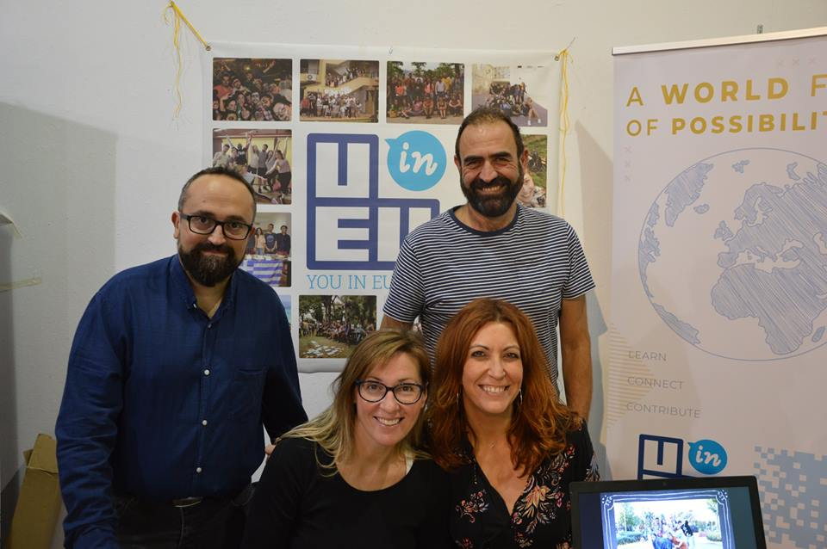

3. The project
"The Sardine Festival" which has been taking place for 36 years, is an 8-day cultural event involving music, theater, dance, visual arts, where local and European bands and teams are invited and hosted to present their repertoire in a multicultural atmosphere that gives a multicolored city if you think that tourists, apart from the local residents, attend the 8 day events that peak on the last day with free food (sardine, anchovies, etc.) and drinks. This festival is organized by the Cultural Club “Faros” with which we have a very good cooperation for many years.
As you understand the event requires a large volunteer bid for its successful outcome. Our objective, is to frame this multicultural event of our city with the participation of 20 short term volunteers from different European countries so that the idea of multicultural / multiculturalism becomes practical Organizers of the festival. Volunteering involves the idea and practice of multicultural approach to an event, the socialization of volunteers, but also the contact of the local community with a multicultural environment whose impact can only have a positive impact. In our constant effort to limit the xenophobia of stereotypes and all kinds of discrimination.
In addition volunteers must organize a workshop for the sustainable fishery and how one can keep the sea richness alive saving it from the plastic attack.
Volunteers will work for maximum 35 hours per week, which include all the activities that described below and also gives space for implementing their own initiative. Two days as day off wil be provided but the exact days will be agreed according to the needs of the project. Also, the exact time of holidays (apart from the official holidays) will be arranged after discussion with the hosting organization.

1st week:
- ice- breaking activities
- team building activities
- on arrival training
- get acquainted with the town
2nd week
- get familiar with the activities of the festival
- planning and organizing duties
- preparation for the festival
- workshop about sustainable fishery

3rd week
- Implementation
- Week of the “Sardines’ festival”
4rth week
- Evaluation
- Vacations!!

Below you can see some photos from last year’s short-evs project, during the sardine festival
https://www.youtube.com/watch?v=5B-R9Y039rg
4. Useful Information (tickets, insurance, training,mentor,accommodation etc)
Travel cost reimbursement: Volunteers will be reimbursed for their tickets (airplane, train, bus), both ways, as following:
- For the Spanish volunteers up to 360 euros pp
- For the Slovenian and Italian volunteers up to 275 euros pp
- For Bulgarian volunteers up to 180 euros pp
Accommodation: Volunteers will stay in “EKAVI apartments”in 5 apartments of 4. Some of the volunteers will need to share their beds, because some of them are double beds. In each one there is a bathroom and kitchen
https://letohalkidiki.com/en/kassandra/nea-moudania/villa-ekavi

Meals: Volunteers receive monthly allowance, (120 euros), which they will be spend according to their will. They can cook in their accommodation.
Pocket money: Volunteers will receive pocket money (150 euros) for their personal expenses.
Transportation: The city of NeaMoudania is small and does not have local transportation system. If there are activities in nearby towns, villages etc. the program covers travel cost
Medical coverage: As Hosting organization we ensure that:
- The volunteer is insured by the insurance company of Erasmus+ program. The procedure has to be made by the sending organization.
- And further provided that the conditions hold the European Health Insurance Card.
In any case in Nea Moudania operating state health center and there are private doctors. Nearby, there is the Hospital of Polygyros and hospitals of Thessaloniki.
Training: Volunteers will take part in on arrival training, organized by YOU IN EUROPE. Additionally they will be trained for their job.
Mentor: Mentor will be available when the volunteers will turn to him/her for support and will keep an eye on the needs. He/she will make sure that volunteers get the resources and tools needed to accomplish their tasks but also for their personal needs. It is also important to make sure that volunteer keeps in touch with the native country and his/her circle. For this reasons and also for positive achievements, mentor will have regular meetings with the volunteers.

5. Participating Organizations
1. Asociación Juvenil Intercambia (SPAIN)
2. Vdahnovenie (BULGARIA)
3. Associazione di Promozione Sociale Warrols (ITALY)
4. Javnizavod Center zamlade Domzale (SLOVENIA)
6. Volunteers’ profile
We are looking for 5for motivated and enthusiastic volunteers from each country (20 in total), able to get involved in cooperation and share their experiences and ideas, aged 18-30 years old, which will be chosen according to their motivational criteria, willingness to work in a team as well as commitment and interest to work for the local festival “Sardine’s festival”
More specific:
- GOOD ENGLISH LEVEL
- INTERESTED IN CULTURAL EVENTS
- SUPER MOTIVATED TO LEARN, WORK HARD AND HAVE FUN
- PREFERABLE IF THE KNOW TRADITIONAL DANCES OF THEIR COUNTRY
- ABSOLUTELY NOT JUST INTERESTED IN TOURISM AND PARTY TIME…!!

7. Selection process
The partner organizations are pleased to send us the CV and motivation letter of their candidates who meet the above criteria before the 15th of April 2019.

Email:youineurope.evs@gmail.com

Tickets: The dates of arrival and departure are 22/6/2019 and 21/7/2019, You can buy the tickets not before the 1th of April and after our confirmation of your travel plan. Nearest airport Thessaloniki Makedonia airport (SKG)

At your disposal youineurope.evs@gmail.com
The team of You in Europe.

